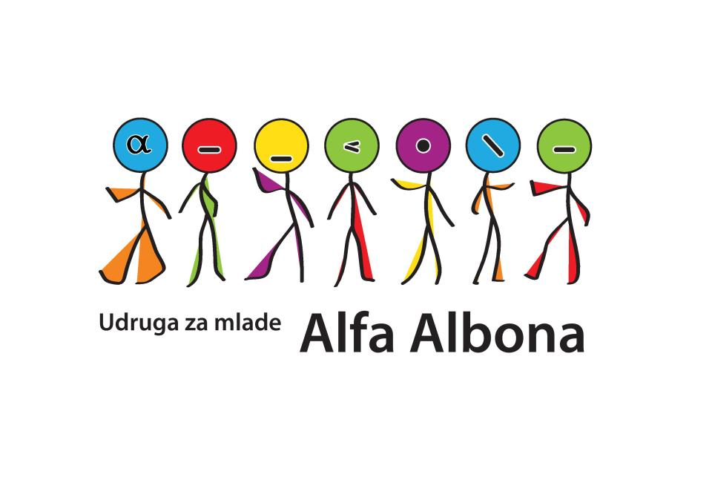
Youth association Alfa Albona

Kalić 2, 52220 Labin
Croatia
www.alfa-albona.hr
e-mail: alfa.albona@gmail.com

EUROPEAN VOLUNTEER SERVICE

VOLUNTEER QUESTIONAIRE

1.) Name and surname

2.) Gender

3.) Date and place of birth

4.) Address and country

5.) E-mail

6.) Skype name

7.) Cellphone number

7.) Passport number and validation (example 14.08.2019.)

8.) Picture

9.) Occupation

10.) Level of English language

11.) Do you recognize yourself in any of the given category (you can pick more choices or none):

- Young person with disability
- Unemployed
- Young person with social obstacles
- Young person from rural place (geographical obstacles)
- Young person that is/has been prosecuted
- Young person with learning obstacles
- Young person with economic obstacles
- Young person with health problems

12.) Specify any food requirements that you have (vegetarian, allergies, etc) and any requirements that you have (mobility, medical condition, religious, etc). Otherwise leave blank.

13.) Describe a place where you are living (city, village, number of citizens) and write do you live in a house, in a flat…

14.) With who do you live with (parents, roommates, brother/sister and do you share room for sleeping…)

15.) Would you feel comfortable to share a room/ tent for sleeping with other volunteers or not? Explain.

16.) How do you feel about working with people different from yourself (racial/ethnic background, developmentally disabled, different socio-economic backgrounds, different sexual orientation…) and did you have any experience like that before?

16.) Do you have any addictions (tobacco, alchocol, drugs, meds…)?

17.) Please rang from 1 to 5 (1 is the lowest, 5 the highest) how important are in your life:

- family

- friends

- work

- leisure time

- religion

18.) Do you speak any other languages beside your mother tongue and English language?

19.) Do you have any experience in volunteering? Tell us about your current and past volunteer experience.

20.) What is your motivation to come to our country and to volunteer in our association?

21.) Do you think it will be easy for you to adapt for living in another country?

22.) What specific skills do you have to contribute our project as a volunteer?

23.) What do you want to accomplish and learn as a volunteer in our association?

24.) What do you find important in volunteer job (working hours, people you are working with, self initiative in projects and workshops, learning new skills…)? Explain.

25.) Do you have experience in working with youth?

26.) Do you have some special skills (dancing, juggling, singing, sewing…)?

Thank you for answering our questions! ☺

