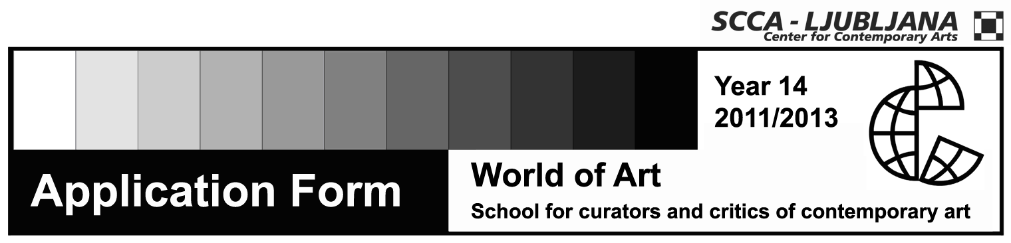

Application Form for the 14th Year of World of Art

Full name

Date and place of birth

Full address

Address for mailing

Phone

E-mail

Status

Signature

Attach to the application form:
- CV
- Review of selected exhibitions of contemporary art (up to 40 lines)
- Motivation letter

Send or bring the application form with attachments to SCCA-Ljubljana.
We will only consider applications that will be submitted until Tuesday, October 11th 2011.

Registration fee: 500 euro
The payment deadline: November 15th 2011 (250 euro), November 15th 2012 (250 euro)

Contact: | Zavod SCCA-Ljubljana, Metelkova 6, 1000 Ljubljana  (Office hours: Monday-Friday, 9 am-1 pm)  Sonja Zavrtanik and Saša Nabergoj  tel.: +386 (0)1 431 83 85  faks. +386 (0)1 430-06-29  e-mail: svetumetnosti@scca-ljubljana.si  www.worldofart.org

