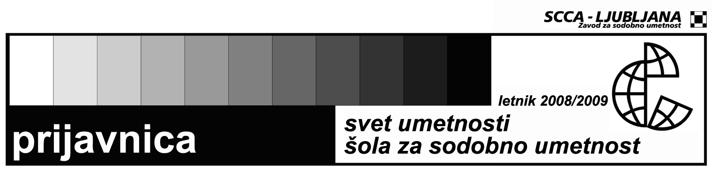

SEMINAR IN WRITING ON CONTEMPORARY ART
"INTERPRETING AND SITUATING CONTEMPORARY ART: OBSERVATION, PARTICIPATION, MOTIVATION, RESEARCH AND EMPATHY"

Name and surname

Date and place of birth

Permanent residence

Address to which I want to receive mail

Phone number

E-mail

Status

Signature

Attach to the registration
- a short biography and a motivation letter
The price for the workshop is je 25 EUR for individuals and 35 EUR for representatives of the institutions.
The registration should be sent to the address svetumetnosti@scca-ljubljana.si by 11th of May 2009. The workshop will be conducted in Serbian language.
Contact: | Zavod SCCA-Ljubljana, Metelkova 6 (working hours: 11.00-13.00)  Petja Grafenauer, Dušan Dovč  tel.: 01 431 83 85, fax: (01) 430 06 29  e-mail: svetumetnosti@scca-ljubljana.si

