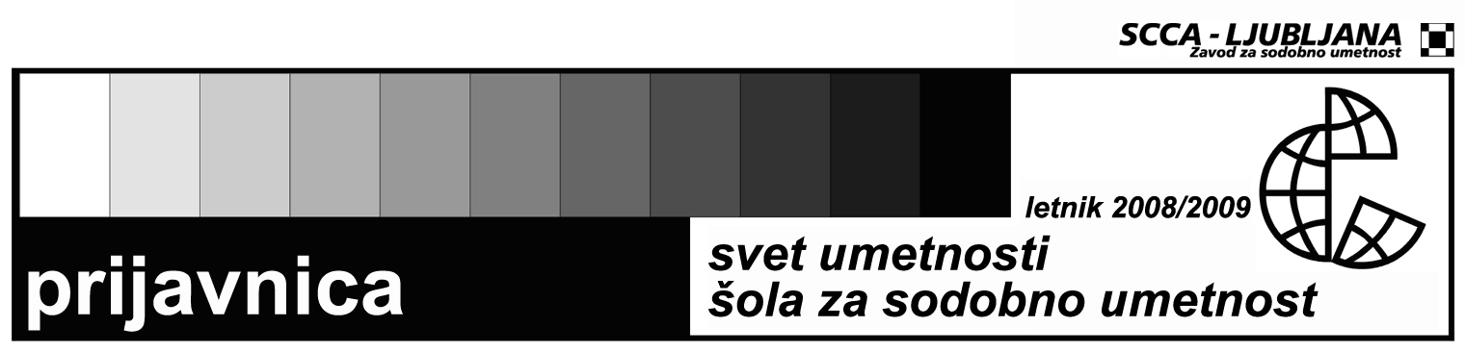

SEMINAR IN WRITING ON CONTEMPORARY ART
Registration form for the workshop: Techniques of Viewing: Representation and Interpretation of Video Art, Angela Harutyunyan
Name and surname

Date and place of birth

Permanent residence

Address to which I want to receive mail

Phone number

E-mail

Status

Signature

The price for the workshop is je 20 EUR for individuals and 30 EUR for representatives of the institutions.
The registration should be sent to the address svetumetnosti@scca-ljubljana.si. The workshop will be conducted in english language.
Contact: | Zavod SCCA-Ljubljana, Metelkova 6 (working hours: 11.00-15.00)  Petja Grafenauer  tel.: 041 367 425, fax: (01) 430 06 29  e-mail: svetumetnosti@scca-ljubljana.si

