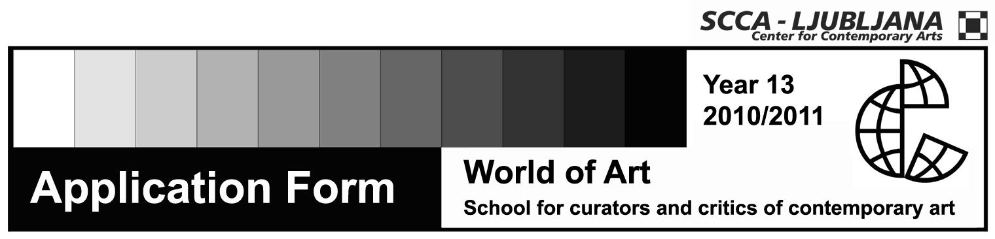

WORKSHOP IN WRITING ABOUT CONTEMPORARY ART

Text for a Catalogue
Tutor: Suzana Milevska

Name and surname

Date and place of birth

Permanent residence

Address to which I want to receive mail

Phone number

E-mail

Status

Signature

The price for the workshop is je 20 EUR
The application form and a short CV should be sent either to email address: svetumetnosti@scca-ljubljana.si, postal address or in person to: Zavod SCCA-Ljubljana, Metelkova 6, 1000 Ljubljana.
The workshop will be held in English.
Application deadline: Friday, January21st

Number of participants is limited.
Contact: | Zavod SCCA-Ljubljana, Metelkova 6 (working hours: 10.00-13.00)  Sonja Zavrtanik  tel.: 01 431 83 85, fax: (01) 430 06 29  e-mail: svetumetnosti@scca-ljubljana.si

