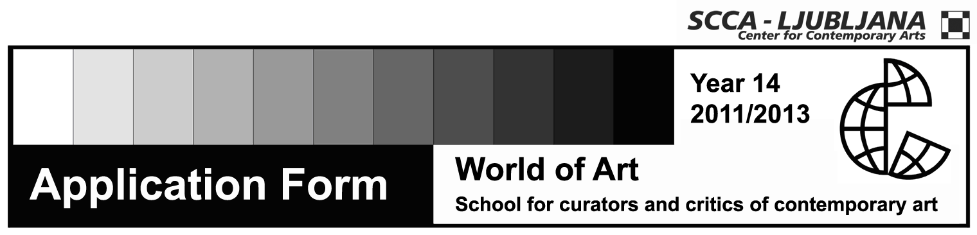

WORKSHOP IN WRITING ABOUT CONTEMPORARY ART
Art and Politics: Contemporary Aesthetics, Philosophy, Theory and Art in the Era of Global Transition
Tutor: Miško Šuvaković

Name and surname

Date and place of birth

Permanent residence

Address to which I want to receive mail

Phone number

E-mail

Status

Signature

The price of the workshop is for individuals 20 € eur and for institutions 30 € (with DDV).
The application and a short CV form should be sent either to email address: svetumetnosti@scca-ljubljana.si, postal address or in person to: Zavod SCCA-Ljubljana, Metelkova 6, 1000 Ljubljana.
The workshop will be held in Serbian language.
Contact: | Zavod SCCA-Ljubljana, Metelkova 6, 1000 Ljubljana  (Office hours: Monday-Friday, 10 am-1 pm)  Saša Nabergoj and Simona Žvanut  tel.: +386 (0)1 431 83 85  faks. +386 (0)1 430-06-29  e-mail: svetumetnosti@scca-ljubljana.si  www.worldofart.org

